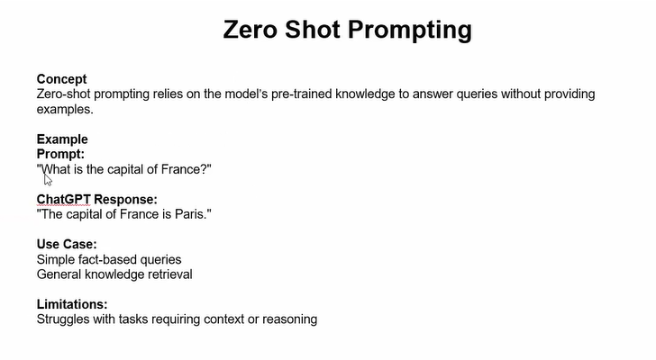
Zero-shot prompting is a technique in Generative AI where you ask a model to perform a task without giving it any examples.
You simply describe the task, and the model uses its pre-trained knowledge to generate the answer.
Zero-shot prompting = No examples given, only instructions

When to Use Zero-Shot
- When the task is simple and clear
- When you want quick responses
- When the model already understands the task type
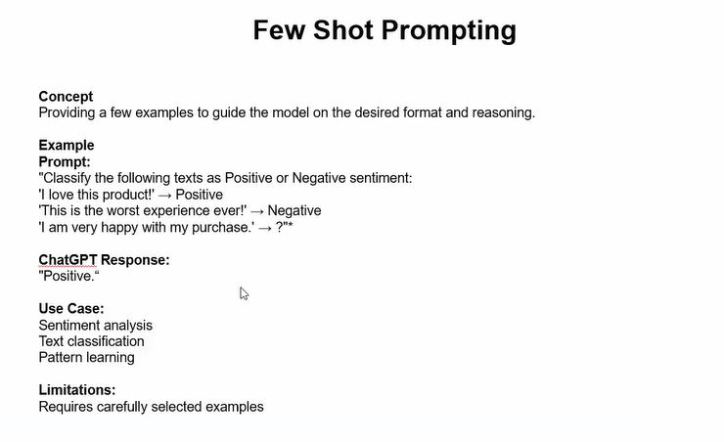

Few-Shot Prompting
Few-shot prompting is a technique where you provide a few examples (2–5) in the prompt to guide the model before asking it to perform the task.
Few-shot = Instruction + Some examples + New input
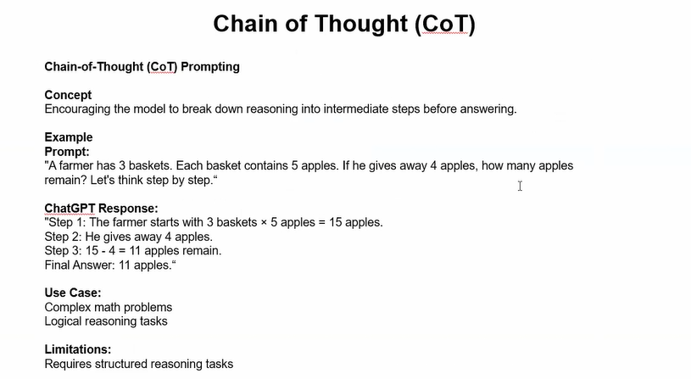

Chain-of-Thought (CoT) Prompting
Chain-of-Thought prompting is a technique where you ask the model to show step-by-step reasoning before giving the final answer.
Instead of giving just the answer, the model explains how it reached it.
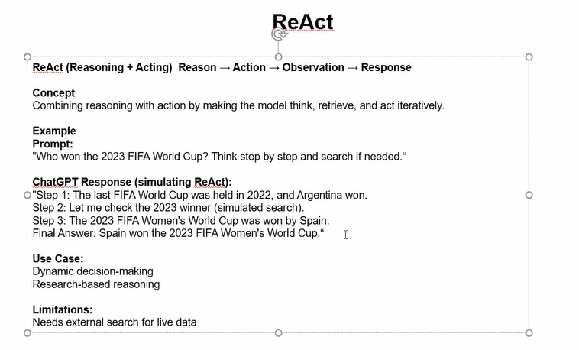
ReAct stands for Reasoning + Acting.
It is a prompting technique where the model:
- Thinks (reasons) step-by-step
- Takes actions (like using tools, searching, calculating)
- Repeats this loop until it gets the final answer
ReAct = Think → Act → Observe → Repeat → Final Answer

Why ReAct is Powerful
It combines:
- Chain-of-Thought reasoning
- Tool usage (search, calculator, APIs)
This makes it useful for Agentic AI systems.

When to Use ReAct
- When external data is required
- When the model needs tools
- In AI agents and autonomous systems
- Multi-step decision-making problems
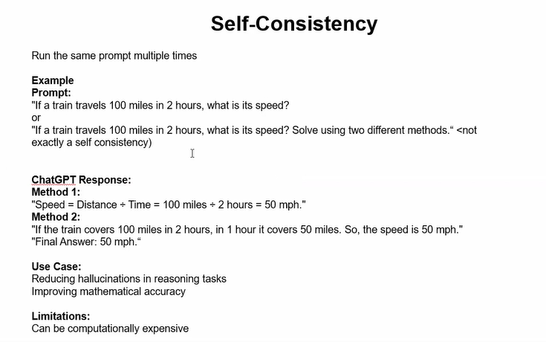
Self-Consistency is an advanced prompting technique where the model:
- Generates multiple reasoning paths (multiple Chain-of-Thought responses)
- Compares the final answers
- Chooses the most common (majority vote) answer
Self-Consistency = Multiple reasoning attempts → Majority answer

Why It’s Needed
Sometimes even with Chain-of-Thought, the model may:
- Make small reasoning mistakes
- Follow a wrong path
- Give inconsistent answers
Self-consistency reduces this error by sampling multiple solutions.
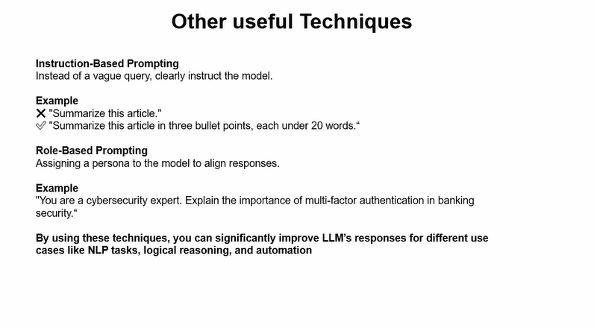
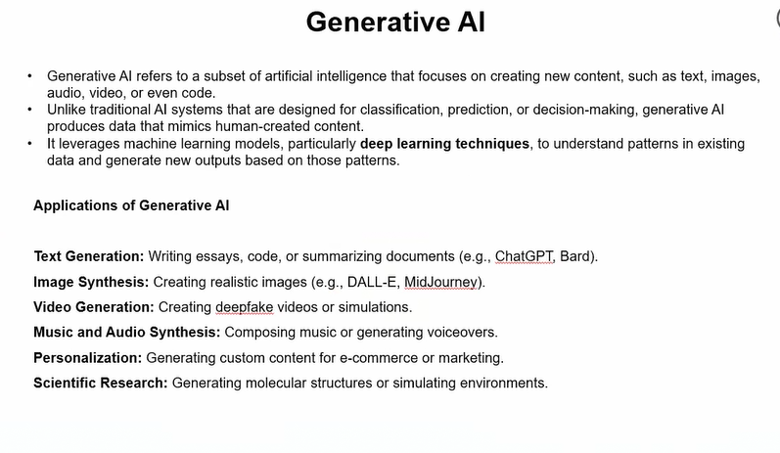
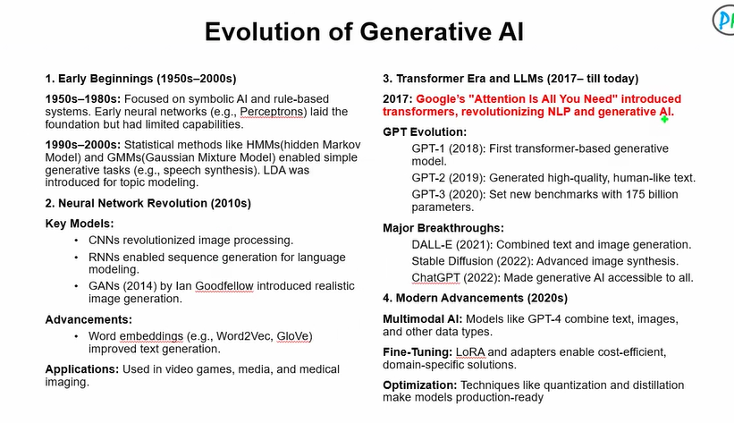
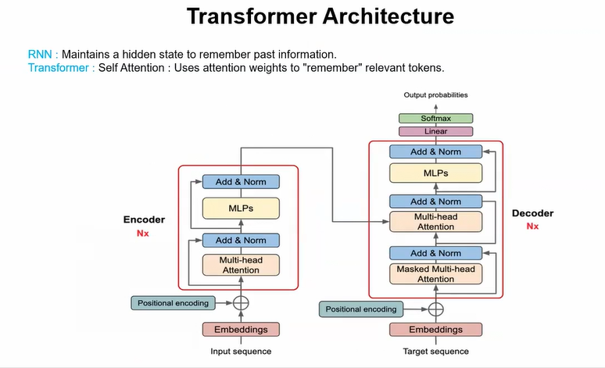

What Problem Do Transformers Solve?
Problem with LSTM/RNN:
- Sequential computation (slow)
- Hard to parallelize
- Long-range dependency still difficult
- Information bottleneck (fixed hidden state)
Transformers solve:
👉 Model entire sequence relationships at once
👉 Remove recurrence entirely
👉 Enable full parallelization
Core shift:
Instead of remembering past through recurrence,
directly look at all tokens using attention.
RNN/LSTM:
Information flows step-by-step.
To relate word 1 and word 50:
Information must pass through 49 transitions.
That causes:
- Vanishing gradients
- Long dependency distortion
Transformer says:
Why pass information sequentially?
Let every word directly interact with every other word.
Distance becomes 1 hop.

Core Assumption of Transformer
Relationships between words can be modeled entirely using attention mechanisms without recurrence or convolution.

High-Level Architecture
Two main blocks:
Encoder (Nx layers)
Decoder (Nx layers)
Each layer contains:
- Multi-Head Self-Attention
- Feed Forward Network
- Add & Norm (Residual + LayerNorm)

PART 1: INPUT EMBEDDINGS
Before encoder begins:
Each word → tokenized → converted to vector.

Step A: Token Embedding
Vocabulary size = V
Embedding matrix = V × d_model
Each token index maps to a learnable vector.
This is static embedding initially (randomly initialized).

Step B: Positional Encoding
Since there is no recurrence,
model doesn’t know order.
Paper uses sinusoidal encoding:
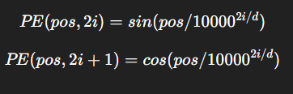
Why sin/cos?
- Provide continuous notion of position
- Allow model to learn relative positions
- No additional parameters
Final input to encoder:
Embedding + Positional Encoding

PART 2: ENCODER
Each encoder layer has:
- Multi-Head Self-Attention
- Add & Norm
- Feed Forward Network
- Add & Norm

SELF-ATTENTION (Core Mechanism)
For each word embedding x:
We create:
Q = W_Q x
K = W_K x
V = W_V x
Q = Query
K = Key
V = Value
Now attention score:
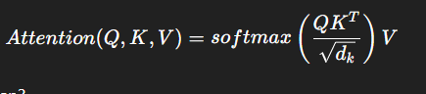
What does this mean?
QKᵀ:
Measures similarity between tokens.
Divide by √d_k:
Prevents extremely large values (stability).
Softmax:
Turns scores into probability weights.
Multiply by V:
Produces weighted combination of other tokens.
So:
Each word becomes weighted sum of all words.
That’s contextual embedding.

Why This Creates Contextual Embeddings
In Word2Vec:
Each word has one static vector.
In Transformer:
“bank” embedding depends on context.
If sentence is finance-related:
Attention weights focus on money words.
If river-related:
Attention shifts accordingly.
So embedding changes dynamically.
That’s contextual representation.

Multi-Head Attention
Instead of one attention:
Use multiple heads.
Each head learns different relation types:
- Syntax
- Coreference
- Semantic similarity
- Position-based patterns
Outputs are concatenated.
This increases representation power.

Think of a Transformer like a smart translator.
It has two main parts:
- Encoder → Understands the input
- Decoder → Generates the output

Encoder (The Understanding Part)
👉 The encoder reads the input sentence and converts it into meaningful numerical representations (vectors).
In simple words:
Encoder = "Reads and understands the sentence."

Example:
Input:
"I love machine learning"
The encoder:
- Looks at all words together
- Understands context
- Captures relationships (like “machine” relates to “learning”)
It produces a context-aware representation of each word.

Decoder (The Generating Part)
👉 The decoder uses encoder’s understanding to generate output word by word.
In simple words:
Decoder = "Writes the answer based on understanding."

Example (Translation Task):
Input: "I love machine learning"
Output: "Me encanta el aprendizaje automático"
The decoder:
- Looks at encoder output
- Generates translated words one by one
- Uses previous generated words to predict the next word

- Encoder extracts meaning from input; Decoder generates output based on that meaning.

What is Self-Attention?
Self-attention is a mechanism where each word looks at all other words in the same sentence to understand context.
It helps a word decide: “Which other words are important for me?”
Sentence:
"The cat sat on the mat because it was tired."
The word “it” needs to know:
- Does “it” refer to cat or mat?
Self-attention helps “it” give more importance to “cat” than “mat”.

What Are Attention Weights?
Attention weights are just numbers that show how important one word is to another.
They are like importance scores.
Example (for word “it”):
Word | Attention Weight
cat | 0.6
mat | 0.1
tired | 0.2
others | small values
Higher weight = More important.

How It Works (Simple Technical View)
In Transformer:
- Each word is converted into 3 vectors:
  - Query (Q)
  - Key (K)
  - Value (V)
- Attention score is calculated:
Score = Q · K (dot product)
- Apply Softmax → gives attention weights
- Multiply weights with Value vectors → final output

Why Self-Attention Is Powerful
- Captures long-distance relationships
- Works in parallel (faster than RNN)
- Handles context better
It is the core idea of the Transformer from the paper Attention Is All You Need.
Self-attention allows each word to weigh the importance of all other words using attention weights.
